
Activity: Exploring Volta’s batteries
Primary level: 11-12 yrs old
Goal of experiment
Fuel cells are essentially Volta-like piles, that use as current generating electrodes hydrogen and oxygen (or ethanol – air, etc) gases instead of metals. The goal of this series of experiments is to deepen knowledge on electrochemistry and Volta’s piles.
Operative (skills) goal: read-out low voltages with a digital meter
Items needed for the experiment (per group):
1. voltmeter with cables and “crocodile”
2. a glass (about ½ l) container, possible „rectangular” in shape
3. distilled water ( ½ l, salt (NaCl), vinegar
4. iron nails, iron paper clip, eurocent coins, pieces of kitchen aluminium foil, other pieces of metals that appear different from iron or copper
5. tea spoon, paper towels
6. some vegetables and fruits (cucumber, lemon, apple)
Instructions for experiments:
Part I
1. Set the voltmeter for voltage readout, 200 meV range (or 2 V)
2. Short cut the two wires of the voltmeter. Write down the readout, repeat twice.
3. Catch the coin and the nail by two crocodiles, shortcut the coin with the nail, read the voltage. Repeat twice, write down.
4. Insert partially a copper coin and an iron nail into your vegetable, measure the voltage.
5. Change the metals, change the distance between them when inserting into the vegetable, write down the voltages read.
6. What is the reason of the voltage that appears? What are the main factors (distance, the type of metal, the type of the vegetable) that influence the voltage read?

Part II
1. Fill container ¾ full of water
2. Insert a paper clip and a strip of aluminum foil into water (the crocodile clips should not be immersed in water; check what happens when you do it)
3. Measure the voltage, measure the current (remember to change the terminals on voltmeter).
2. Attach one test lead from the positive (+) terminal of the supplier to an electrode and attach the second test lead to the negative (-) terminal of the supplier and the second electrode.
3. In-between the supplier and one of the electrodes connect the voltmeter to measure the current (look carefully which connector on the voltmeter is used to measure the electrical current in A)
4. Place the electrodes in the water bath without allowing them to touch. Measure the distance between electrodes.
5. Set the voltage to 0 V and change it every 0,1 V, write down the current value
6. Observe. Do no exceed 3 V on the supplier,
7. Add some (one tea spoon) of salt to water and repeat step 5.
8. Observe
9. If you have still some time left, change the distance between electrodes and repeat point 5.

Electrolysis 2 - worksheet
Name ___________________________________
Hypothesis:
1. What will happen when we place the electrodes attached to the battery into the water bath?

2. Why is it important not to allow the electrodes to touch each other?

3. What will happen when we add salt to the water bath?

Observations:
1. What do you see on each electrode? Is it the same on both electrodes? What is the difference? When (under which voltage) you see this?

2. What difference did adding salt make?

3. The chemical formula of water is H₂O: it means that water is composed of hydrogen (a light gas that burns) and of oxygen (a gas needed for breathing and burning). Hydrogen is twice as much as oxygen. Thermodynamics suggests that the threshold value for producing hydrogen should be higher than 1,23 V, but this value does not take into account some processes linked to the temperature.
What is the threshold value you measured for which hydrogen and oxygen are formed?

Which electrode (positive or negative) is producing oxygen? And which is producing hydrogen? How can you tell it?

4. Complete the reaction: H₂O → …. + ….
Conclusions:
1. How could we trap the gas being produced at the electrodes?

2. What applications would these trapped gases be useful for?

Discussion
Alessandro Volta in 1797 noticed that electrical current (he measured it by his own tongue) appears when two metals are connected via a liquid. Now we know, that the voltages depend essentially only on the type of metal. We can make a series, where in the middle, with the value 0 is hydrogen, with values positive are copper, silver, gold, and with values negative are zinc, aluminum, iron etc.
To know which voltage will be created we must calculate the difference between the potentials of two electrodes, for example xxx
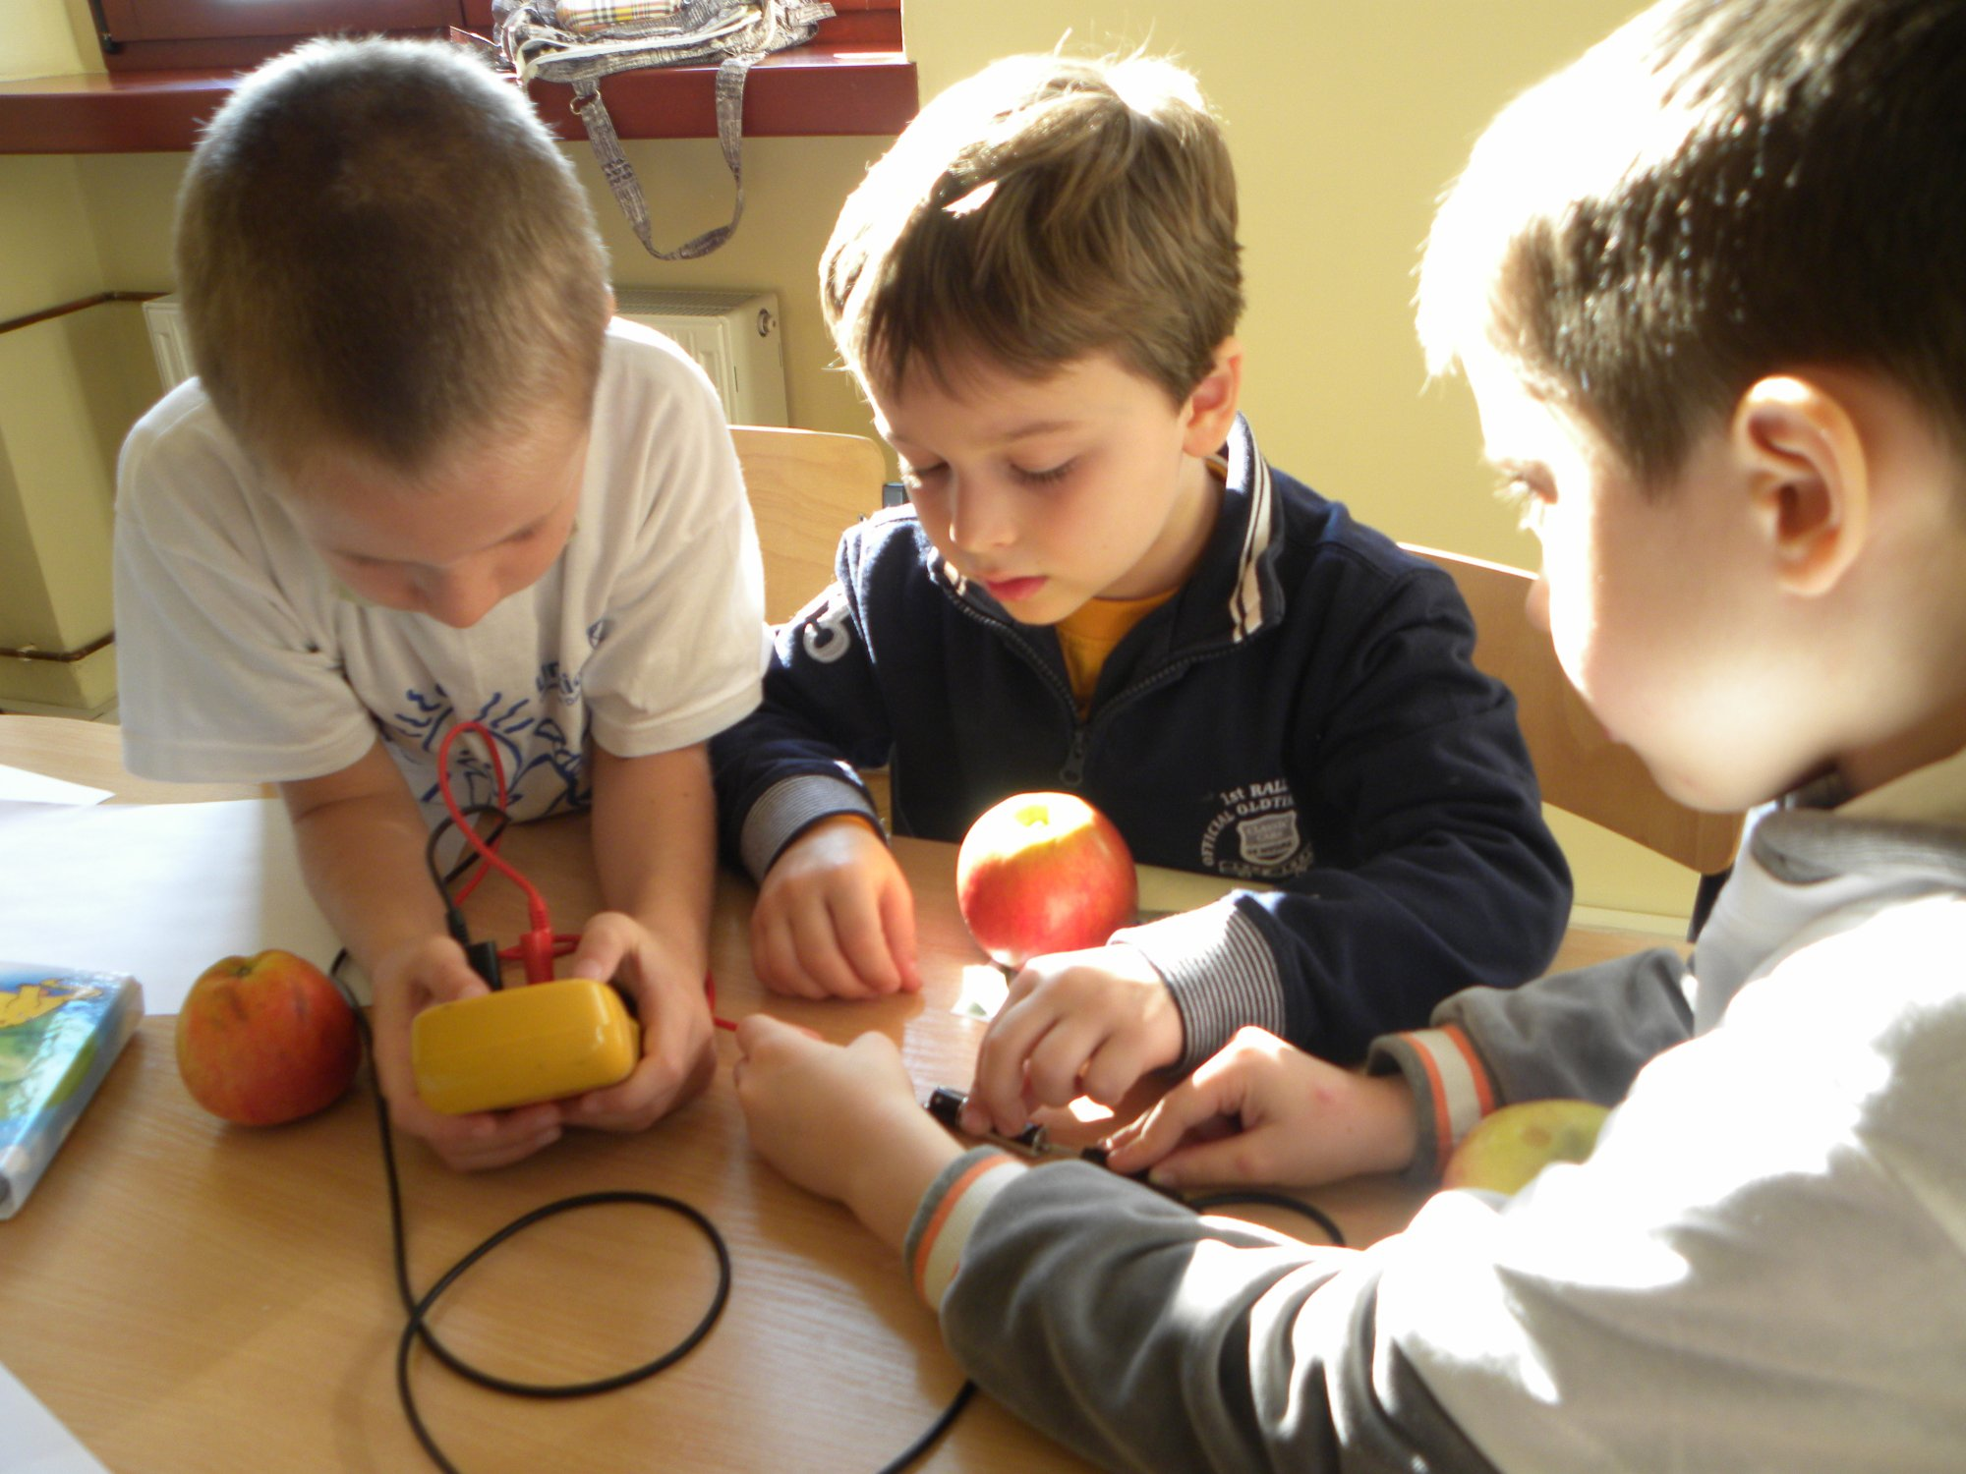

(GK, KF)

Dołączaom wartości w serii Volty
Li+(aq) + e− → Li(s) | −3,04
2H2O(l) + 2e− → H2(g) + 2OH−(aq) | −0,828
Zn2+(aq) + 2e− → Zn(s) | −0,762
PbO(s) + H2O + 2e− → Pb(s) + 2OH− | −0,576
Fe2+(aq) + 2e− → Fe(s) | −0,41
Sn2+(aq) + 2e− → Sn(s) | −0,14
Pb2+(aq) + 2e− → Pb(s) | −0,13
2H+(aq) + 2e− → H2(g) | 0,00
Sn2+ (aq) + 2 e− → Sn(s) | 0.14
Cu2+(aq) + 2e− → Cu(s) | 0,34
Ag+(aq) + e− → Ag(s) | 0,80
F2(g) + 2e− → 2F−(aq) | 2,87

